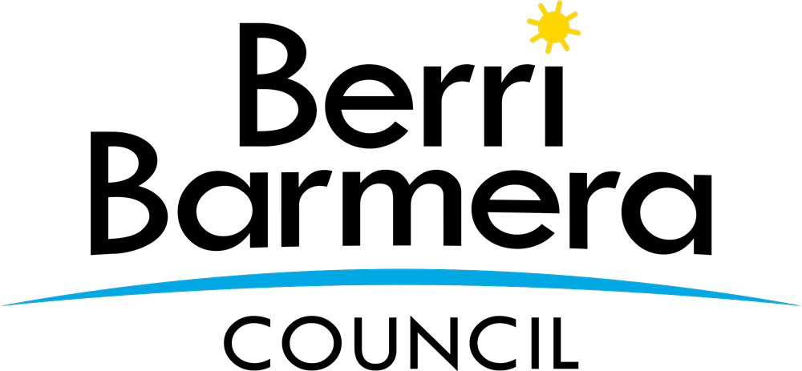 | Berri Barmera Council  Centenary Grants Scheme

Acquittal Form

Introduction

The Centenary Grants Scheme is a one-off initiative to support community groups and organisations by providing financial and in-kind support to enhance their capacity to provide Barmera, Monash, Glossop, Loveday, Cobdogla and Overland Corner Centenary orientated programs and events within the Berri Barmera Council area during the 2021 year.

This acquittal is to be submitted no later than six (6) weeks after completion of the program, activity or event.

1. Grant Recipient’s Details

Organisation Name
Postal Address
Contact person for this application
Contact person position in organisation
Phone number
Mobile phone number
Email address
Program / event / activity title
Program funding provided | $
Program funding spent | $
Amount to repay | $
Date project completed

2. Project Summary

Project Outcome

Describe the project and the results achieved, include information detailing the benefits to the community. Include an estimate of the number of people that benefited / attended the program / event / activity. Support material such as photos may also be included.

How was the support acknowledged?

Describe how the support was acknowledged. Attach copies of any publications and publicity material.

3. Financial Summary

Project Financial Report

Provide a detailed breakdown of how the grant funds were spent. Provide copies of invoices or documents to support your acquittal.
ATTACHMENTS

Please list any attachments provided e.g. photos, promotional materials, copies of invoices etc.

4. Certification

I certify that I am authorised by the applicant to prepare and submit this acquittal for funds received under the Centenary Grants Scheme.

I certify that the information provided in this acquittal report, including relevant attachments are true and correct. I agree to provide Berri Barmera Council with additional information on the funded activity if required.

Name (please print) Signature

_/ _/ Position Date

5. Lodgement of Acquittal

Acquittals may be posted, hand delivered or emailed to:

POST:-
Library Manager
Berri Barmera Council
PO Box 229
Berri SA 5343

DELIVERY ADDRESS:-
Library Manager
Berri Library
Kay Avenue
Berri SA 5343

EMAIL:-
Email: pison@bbc.sa.gov.au

