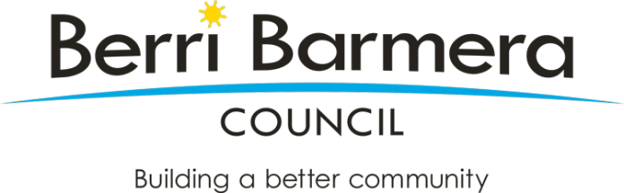
FREQUENTLY ASKED QUESTIONS
Berri Hard Waste Collection 2022

What is hard waste?
Hard waste includes items that are too large to dispose of through regular household waste collections.
What will be provided for Berri residents in the 2022 hard waste collection project?
A kerbside hard waste collection service will be provided for in-town residents residing in a property with a street number (not a rural address).
I live in another town, why am I not getting a hard waste collection this year?
This collection is being offered to residents on a three-year rotational basis commencing with Berri township residents in the 2021/2022 financial year. This rotation through the district will help to split the cost to Council while still ensuring an equitable service for all residents of this very popular service.
Who is eligible for the collection?
For a residential property to be eligible they must be located within township boundaries, which is defined as having a street address not a rural address.
Excluded properties include, but are not limited to;
- businesses,
- commercial premises,
- vacant land,
- industrial properties,
- schools and churches.
When can I put my items out?
To make sure your items are collected residents are asked to put items out for collection between Wednesday 1 June and Sunday 5 June 2022. Items placed out after this time might be missed and no follow up collections will be undertaken.
What items can I place out?
A list of accepted and excluded materials can be found below
Are E-Waste (Computer, scanners, televisions, DVD players) included?
Yes, these items will be collected, a listing has been included below.
Will mattresses be collected?
Yes, mattresses will be included.
Can I put my items out early?
If you put your waste out before the dates advised above, you risk being fined for illegal dumping.
Council is enforcing illegal dumping and we are trying to minimise the time that hard waste is left on footpaths.
Some of my items have not been collected. Why?
Cleanaway may elect to not collect waste if the following occurs:
- the waste placed out exceeds the allowable 2m³ limit
- items that are not eligible for collection have been placed out (please see below for a list of acceptable items)
if you have uncollected items, written notice will be provided by the contractor.
If you receive a notice then you must remove the uncollected items within 24 hours. It is the residents responsibility to do this and failure to do so may attract a fine.
Some things are just too good to throw away!
Your old furniture, toys and equipment might be useful to someone else.
Please consider the following options:
- Hold a garage sale
Garage sales are easy to organise and you may even profit from items you intended on disposing.
- Donate to an op shop
Why not ring up an op shop and see if they would accept the items you no longer have a use for? Someone could be very grateful for your donation.
- Advertise as a give-away item
There are a number of different platforms that can be utilised to advertise give-away items. These platforms include Facebook and Gumtree which are both simple to use and free to advertise on.
- Repurpose
As the Earth’s population increases – so does the quantity of waste produced. Why not take a more sustainable approach and repurpose items you intend on disposing.

Accepted Materials:
- Empty paint tins with lids removed
- Furniture, bedding, carpets, rugs and mats
- Medium to large general waste items able to be handled by two people
- Non-metal and non-electrical tools and gardening equipment
- Polystyrene and other plastic packaging
- Pottery, crockery and wash basins
- Pyrex glass (e.g. microwave dishes) and intact mirrors
- Hot water units, tanks and empty drums able to be handled by two people
- Lawn mowers, small combustion equipment, metal tools and gardening equipment
- Metal baths and Roofing iron and guttering other metal items up to 1.5 metres in length and able to be handled by two people
- Small metal car parts weighing less than 20 kilograms
- Any other scrap metal material
- Fridges and freezers with doors removed
- Washing machines, dryers and stoves
- E-Waste (anything that is domestic, plugs into a power point, uses a charger or is powered by battery)
- Mattresses

Excluded Materials:
- Cans or tins containing liquid paint or other liquids
- Car bodies, large car parts, tyres or large scrap metal items above 1.5 metres unable to be handled by 2 people
- Concrete, asbestos, bricks, rocks, dirt
- Items placed in plastic bags that appear to be hazardous in nature
- Gas bottles, ammunition or explosives
- Domestic recyclables such as glass and plastic bottles, jars and other containers suitable for collection through the kerbside comingled recycling collection service
- Large sheeting and plasterboard sheeting unable to be handled by 2 people
- Liquid waste
- Obvious business waste (e.g. large volumes of identical material or items)
- Other hazardous waste items as defined under the Environment Protection Act
- Large tree stumps unable to be handled by two people

