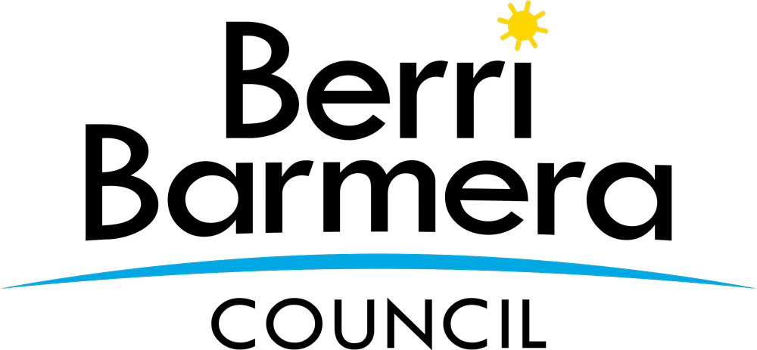 | Berri Barmera Council  Centenary Grants Scheme

Apply for a Grant

The Centenary marking the proclamation of the towns of Barmera, Monash and Glossop occurs in 2021 and a number of community groups and organisations from these towns and surrounding areas are in the process of facilitating projects and events to celebrate the last 100 years.

The Centenary Grants Scheme is a one-off initiative to support community groups and organisations by providing financial and in-kind support to enhance their capacity to provide Barmera, Monash, Glossop, Cobdogla, Loveday and Overland Corner Centenary orientated programs and events within the Berri Barmera Council area during the 2021 year.

The applicant must be based in the Berri Barmera Council region, have a membership base within the Berri Barmera Council, and be delivering a service which will be of a direct benefit to members of the Berri Barmera Council community.

The scheme offers the chance to receive up to $5,000 in grant funding to help deliver a program, event, activity or initiative.

Everything you need to know about the program and how to apply can be found on Council’s website
www.bbc.sa.gov.au

Prior to completing an application it is recommended to read the Centenary Grants Scheme Conditions.

Applicants may submit multiple applications per funding round but limited funds are available through a competitive process. No applicant is guaranteed to receive approval for all or any funding applied for.

Applicants wishing to apply for more than one event per funding round are required to complete one application form for each program, event or activity.

For further information about the program please contact Council’s Library Manager, Peter Ison at email: pison@bbc.sa.gov.au or phone: 0428883177

Key Dates – Round 1

30 October 2020
Applications close
20 November 2020
All applicants notified of the outcome of their application

Key Dates – Round 2

30 April 2021
Applications close
21 May 2021
All applicants notified of the outcome of their application

Key Dates – Round 3 (Applications open on 4 August 2021)

1 September 2021
Applications close
15 September 2021
All applicants notified of the outcome of their application

