Categories:

Citizen of the Year
To be eligible, the person must be an Australian Citizen.

Young Citizen of the Year
To be eligible, the person must be at least 16 years of age, but under 30, on 26 January of the Awards year.

Community Event of the Year
This is presented to the person/group who has staged the most outstanding community event during the past year.

Building a Better Community
This Award would be for a activity, project or group delivering outstanding work that has significantly benefited our community during the past year.

Procedure:
Each local Council in South Australia seeks nominations in their local Council area, with the award recipients typically announced at the Council’s Australia Day celebrations.
Councils can forward the details of their Award recipients to the Australia Day Council of SA
to go in the running for the State Awards, presented by the Governor of South Australia.

The Australia Day Citizen of the Year Awards are proudly presented by the Australia Day Council of South Australia, sponsored by On the Run, Sarah Constructions and the Local Government Association of South Australia. The Citizen of the Year Awards are administered by local Councils across SA.
The Awards reward and recognise individuals and organisations that have made a noteworthy contribution during the current year, and/or given outstanding service over a number of years, to a local community over and above normal employment duties.
Who makes a difference
in your community?
Nominations are now open:
- Citizen of the Year
- Young Citizen of the Year
- Community Event of the Year
- Building a Better Community
Awards are presented at our Australia Day breakfast on Wednesday 26 January 2022 on the Berri Riverfront
For further details contact us on 8582 1922 or visit our website www.berribarmera.sa.gov.au/COTY
Outstanding contribution and community service include areas such as education, health, fundraising, charitable and voluntary services, business, sport, arts, the environment, or any other area that contributes to the advancement and well being of a community.
Nominate someone who makes a real difference in your community and give them the opportunity to be rewarded and recognised for their important contribution.
Visit the website:

www.berribarmera.sa.gov.au/COTY

to nominate online and for more information on the awards, including past winners.

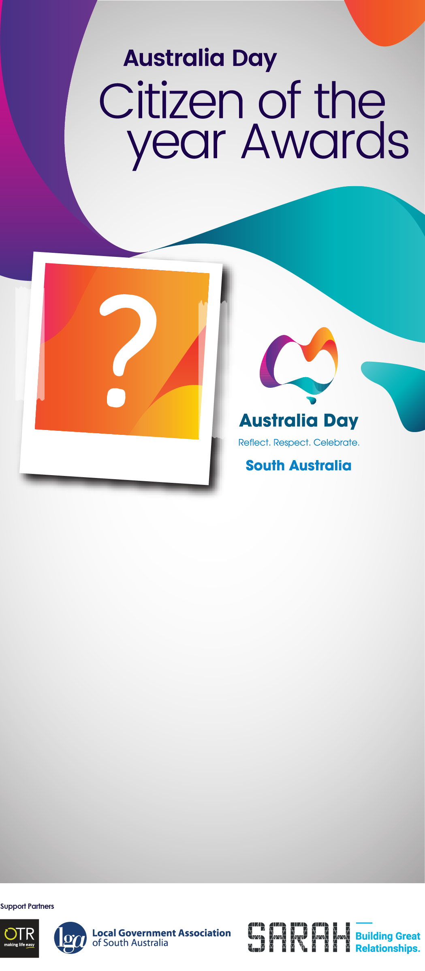

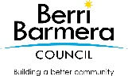

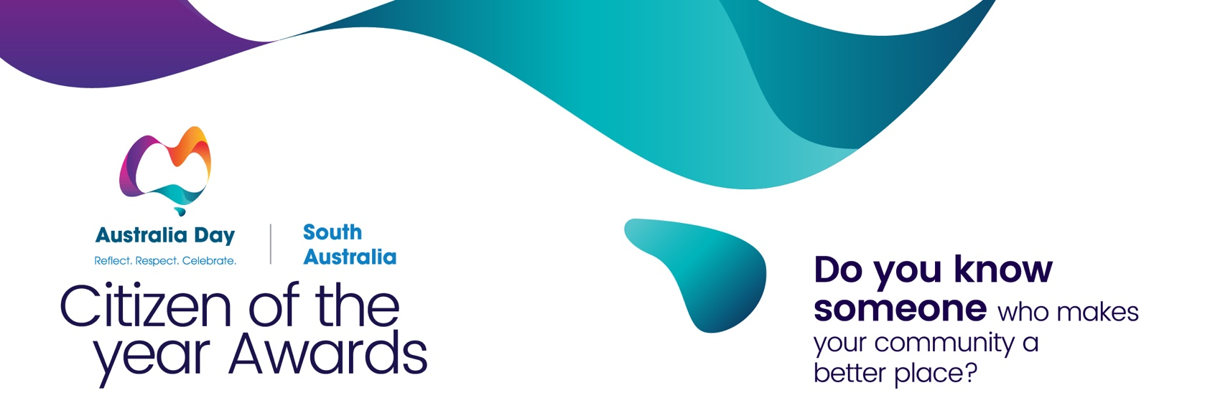

Nomination Form:
Nominee (the person/organisation you would like to nominate)
Please provide as much information as possible. Additional documents may be attached providing further
information or testimonials of achievement.

Award Category (please tick)

☐ CITIZEN ☐ YOUNG CITIZEN ☐ COMMUNITY EVENT ☐ BUILDING A BETTER COMMUNITY
Name: Click or tap here to enter text.
Address Click or tap here to enter text.
Phone: Click or tap here to enter text. Date of Birth: Click or tap here to enter text.
Email: Click or tap here to enter text.
Is the person being nominated an Australian citizen? ☐ YES ☐ NO

Reason for nomination
Why do you believe the nominee should be awarded Citizen/Young Citizen / Community Event / Building a Better Community Award?
Click or tap here to enter text.

How has the person/organisation contributed to making our community a better place?
Click or tap here to enter text.

Who has benefited the most from the nominee’s contribution and/or services (ie community groups, individuals etc)?
Click or tap here to enter text.

Has the person/group overcome any particular challenges, personal sacrifices or adversities to mark their achievement?
Click or tap here to enter text.

Do you know if the person/ organization have any other significant community contributions / achievements (ie awards, certificates) – please list.
Click or tap here to enter text.

Additional material may be attached: maximum five A4 pages, minimum font size 10 point.
Nominator (your details)

Name: Click or tap here to enter text.
Address: Click or tap here to enter text.
Phone: Click or tap here to enter text. Email: Click or tap here to enter text.
☐ I give permission for the Australia Day Council of South Australia to submit this nomination to other recognition programs such as the Australian of the Year Awards.

Please return completed form before Friday 12 November 2021 to:
Berri Barmera Council, 19 Wilson Street, BERRI SA 5343 or via email clemaistre@bbc.sa.gov.au

