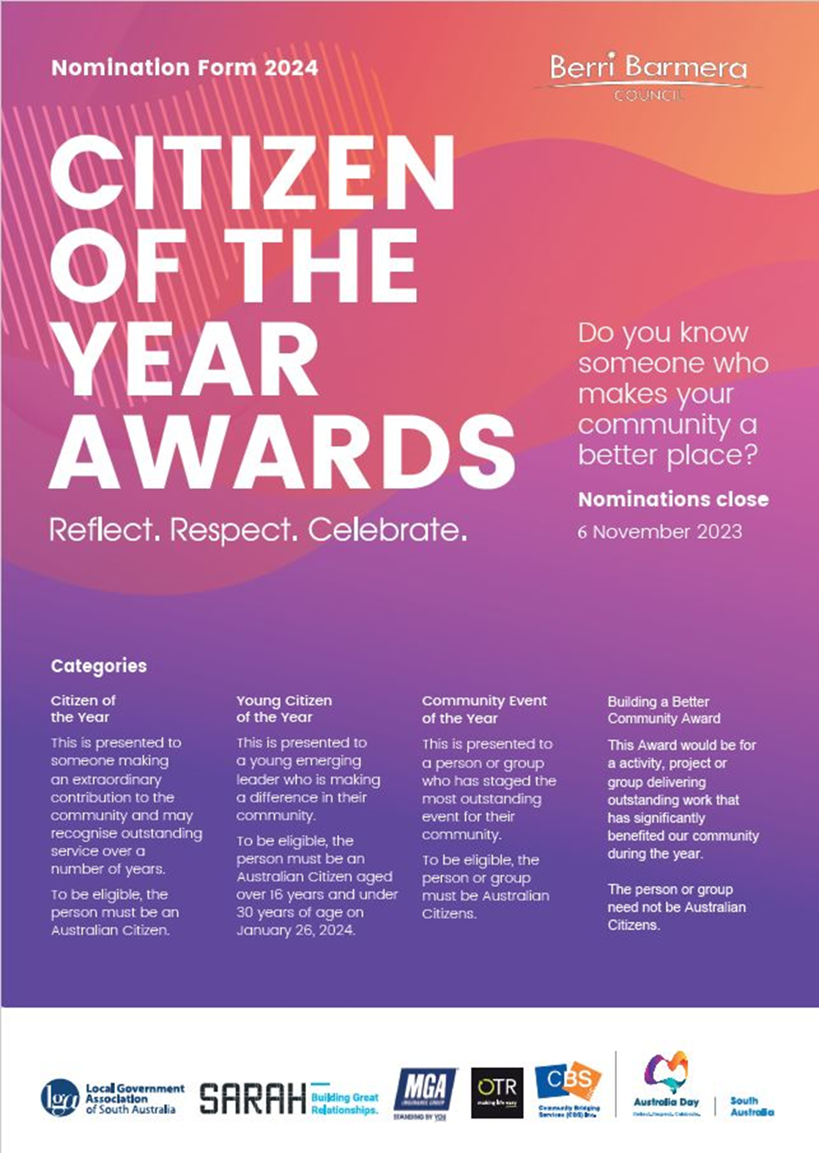

## Nomination Form 2023

The Citizen of the Year Awards are proudly presented by the Australia Day Council of South Australia, sponsored by On the Run, Sarah Constructions, MGA Insurance and the Local Government Association of South Australia. The Citizen of the Year Awards are administered by local Councils across SA.

The Awards acknowledge the unsung heroes of our community who through their contributions make our state a better place. These individuals and organisations offer outstanding service each day and enable our communities to be stronger as a result of their tireless efforts.

Outstanding contribution and community service includes areas such as education, health, fundraising, charitable and voluntary services, business, sport, arts, the environment, or any other area that contributes to the advancement and well being of a community.

Nominate someone who makes a real difference in your community and give them the opportunity to be celebrated and recognised for their important contribution.

Nominee (the person/organisation you would like to nominate)

Please provide as much information as possible. Additional documents may be attached providing further information or testimonials of achievement.

**Citizen of the Year Award**

□ CITIZEN □ YOUNG CITIZEN □ COMMUNITY EVENT □ ACTIVE CITIZENSHIP

Name:

Address:

Phone: Date of Birth:

Email:

Council:

If you are unsure of the Nominee’s Council, go to [https://www.lga.sa.gov.au/sa-councils/councils-listing](http://www.lga.sa.gov.au/sa-councils/councils-listing) and enter their address in the search ﬁeld of Find My Council by Location

Is the person being nominated an Australian citizen? □ YES □ NO

**Reason for nomination**

How has the person/organisation contributed to the community?

Nominee

##### (the person/organisation you would like to nominate)

Please provide as much information as possible. Additional documents may be attached providing further information or testimonials of achievement.

|  |  |
| --- | --- |
| **Citizen of the Year Award** | |
| CITIZEN  YOUNG CITIZEN  COMMUNITY EVENT  BUILDING A BETTER COMMUNITY | |
| Name: |  | |
| Address: |  | |
|  |  | |
| Phone: | Date of Birth: | |
| Email: |  | |
| Council: |  | |
| If you are unsure of the Nominee’s Council, go to [https://www.lga.sa.gov.au/sa-councils/councils-listing](http://www.lga.sa.gov.au/sa-councils/councils-listing) and enter their address in the search field of Find My Council by Location | |
| Is the person being nominated an Australian citizen?  YES  NO | |
| **Reason for nomination**  Why do you believe this person/organisation should be nominated for an Award? |  | |
|  | |

How has the nominee demonstrated active citizenship and enhancement of community life?

Who has benefited the most from the nominee’s contribution and/or services (ie community/sporting groups, individuals)?

Has the person/group overcome any particular challenges, personal sacrifices or adversities to mark their achievement?

How has the nominee’s contribution been recognised elsewhere?

Additional material may be attached: maximum ﬁve A4 pages, minimum font size 10 point.

# Referee

Please provide the contact details of a referee or attach a written reference. Name:

Phone:

Email:

Occupation:

What is the referee’s relationship to the nominee?

What can the referee comment on?





Nominator (your details)

Name:

Phone:

Email:

I give permission for Berri Barmera Council to submit this nomination to other recognition programs such as the Australian of the Year Awards.

## Procedure

Berri Barmera Council seeks nominations from our local district, with the successful Award recipients to be announced on Australia Day 2024.

Councils will forward details of their Award recipients to the Australia Day Council of SA to go in the running for the State Awards, presented by the Governor of South Australia.

Visit the website to nominate online and for more information on the Awards, including past recipients.

### [www.berribarmera.sa.gov.au/COTY](http://www.berribarmera.sa.gov.au/COTY)

**Please return completed form by 10.00am Monday 6 November 2023 to:**

Berri Barmera Council, 5 Riverview Drive, Berri SA 5343 or via email [bbc@bbc.sa.gov.au](mailto:bbc@bbc.sa.gov.au)

#### **How did you hear about the Citizen of the Year Award?:**

#### Social media

#### Newsletter

#### Website

#### Newspaper article

#### Word of mouth

#### Information in Council office

#### Nominated before

#### Other, please specify

#### Click or tap here to enter text.