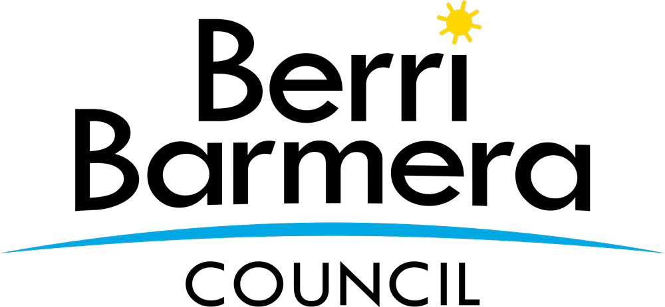 | Berri Barmera Council  Centenary Grants Scheme

Application Form

Introduction

The Centenary Grants Scheme is a one-off initiative to support community groups and organisations by providing financial and in-kind support to enhance their capacity to provide Barmera, Monash, Glossop, Cobdogla, Loveday and Overland Corner Centenary orientated programs and events within the Berri Barmera Council area during the 2021 year.

If you are planning to conduct an event or activity to celebrate the Centenary, before completing an application you should approach either the Barmera Centenary Committee or the Lone Gum and Monash Community Association Inc This will ensure that your event can be coordinated, or perhaps be joined with other planned Centenary programs, events or activities. To contact either of these groups directly, email the Barmera group at centenary2021@barmeratourism.com.au (or by telephone on 8588 2289) or email the Monash group at ali@grantsheds.com.au (or by telephone 8583 5262).

Before completing this application please ensure that you read the Centenary Grants Scheme Conditions which provides the details of the program, eligibility criteria and the process when applying.

Applications for consideration are to be made in writing on the approved application form. All applications should be typed or neatly handwritten with support documentation attached to the application. Please provide an answer to all questions as required.

1. Applicant Details

Organisation Name
Postal Address
Contact person for this application
Contact person position in organisation
Phone number
Mobile phone number
Email address
Is your organisation not for profit? |  Yes  No
Organisation ABN
Is your organisation registered for GST |  Yes  No
Is your organisation Incorporated |  Yes  No
Incorporation Number
Does your organisation have Public  Liability Insurance |  Yes  No

2. Program Details

Program / event / activity title
(have you checked with the relevant Centenary Committee to see if your event can be coordinated with other events?)
Program / event / activity description
(if multiple, please complete a separate grant application for each)
Program / event / activity start date

Program / event / activity / completion date
Physical location of program / event / activity – must be within the Berri Barmera Local Government Area
Who will be involved in the program /
event / activity – include any partnering organisations
How will your program / event / activity provide a direct benefit to the
community?
Is this a one-off program / event /  activity? |  Yes  No
If it is not a one-off program / event /
activity, how will you fund this in the future?
What type of assistance are you requesting? |  Financial support  In-kind support
Amount of financial assistance requested | $
Details of in-kind support requested
Program budget cost breakdown - how
will the funds be spent – provide a list of program items and costs
Have you sought funding through other  avenues for your program, event or activity? |  Yes  No  If yes please provide organisation / individual name and contribution amounts.
Do you have other Barmera, Monash, Glossop or outlying towns Centenary orientated programs and events planned during the 2021 year? |  Yes  No  If yes please provide brief details.
Please provide any further information considered relevant in support of the
program, event or activity that has not been provided elsewhere in the application or supporting documents.
Attachments – you must attach copies of the following documents. | Certificate of Currency for Public Liability Insurance  Quotes to support your program, event or activity budget  Minutes confirming the decision to seek financial assistance for the program, event or activity  Letters of support for the program, event or activity  Any other documents supporting your application (if applicable)

3. Certification

To be signed by two members of the executive of the organisation.

I certify that I am authorised by the applicant to prepare and submit this application to Berri Barmera Council for consideration under the Centenary Grants Scheme.

I have read the Centenary Grants Scheme Conditions relating to the funding and certify that the information provided in this application is true and correct. I agree to provide Council with additional information if required to assess this application.

I understand that the Berri Barmera Council does not accept any liability or responsibility for the proposal in this application and that it is the responsibility of the applicant to provide the appropriate insurance cover.

If Berri Barmera Council approves the application, I will acknowledge the support of Council in any publications, publicity material or signage associated with the funded program or activity.

I agree to provide a program summary and financial report (acquittal).

Name (please print) Name (please print)

Signature Signature

Position Position

_/ _/
_/ _/

Date Date

4. Lodgement of Application

All applications must be addressed to:

Library Manager
Berri Barmera Council
PO Box 229
Berri SA 5343

